Pokémon Comparator and Information Viewer document

1. Home page

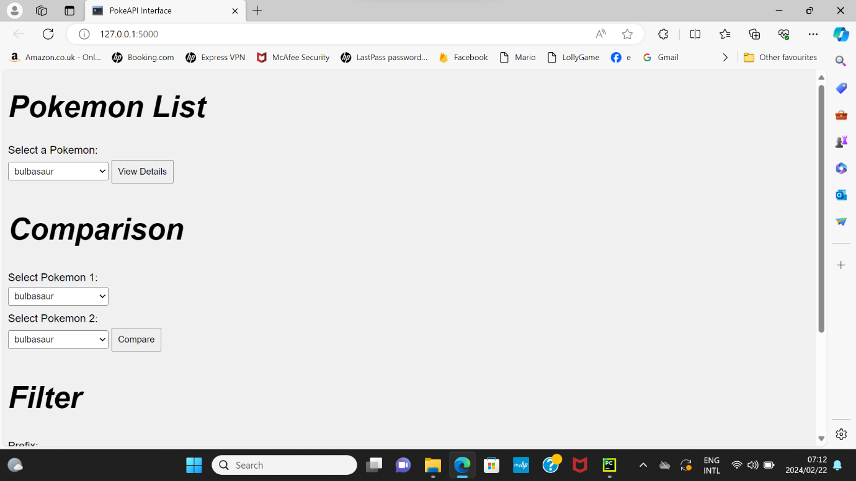

* The home page of the Pokémon comparator consists of there main tabs which include.
* Pokémon list: to view details.
* Comparison: To compare different Pokémon.
* Filter: filter different Pokémon based on a certain criterion.

1. 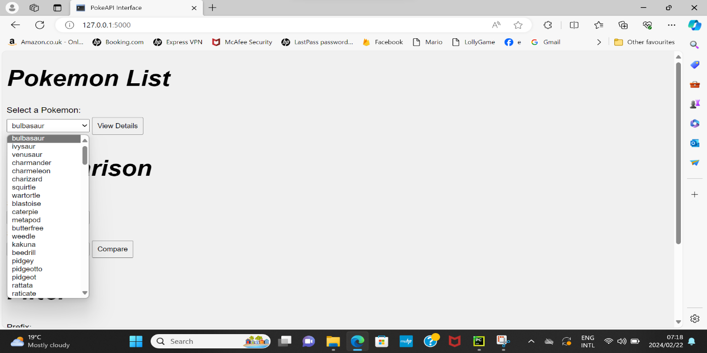Pokémon list

* Under Pokémon list the user will be able to view a list of the 151 Pokémon available, from that list when they select a user, they will be able to view the details of the Pokémon, a short description will be displayed, height, weight and base experience.

1. Comparison

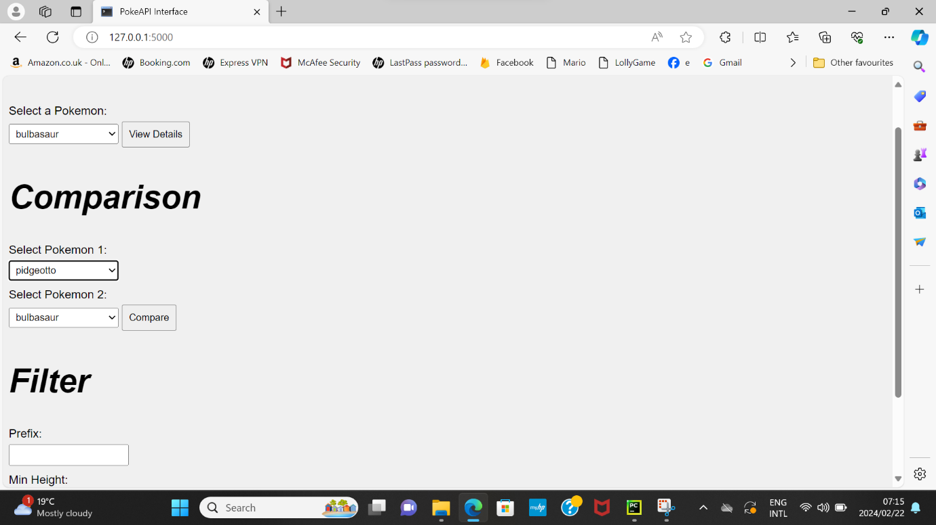

* A screenshot of a computer

  Description automatically generatedThe user will be able to compare two different Pokémon, the results table will show the differences in height, weight and base experience, this will allow the user to determine which Pokémon is the best.

* When a user selects the same Pokémon there won’t be a comparisons results displayed.

1. Filter

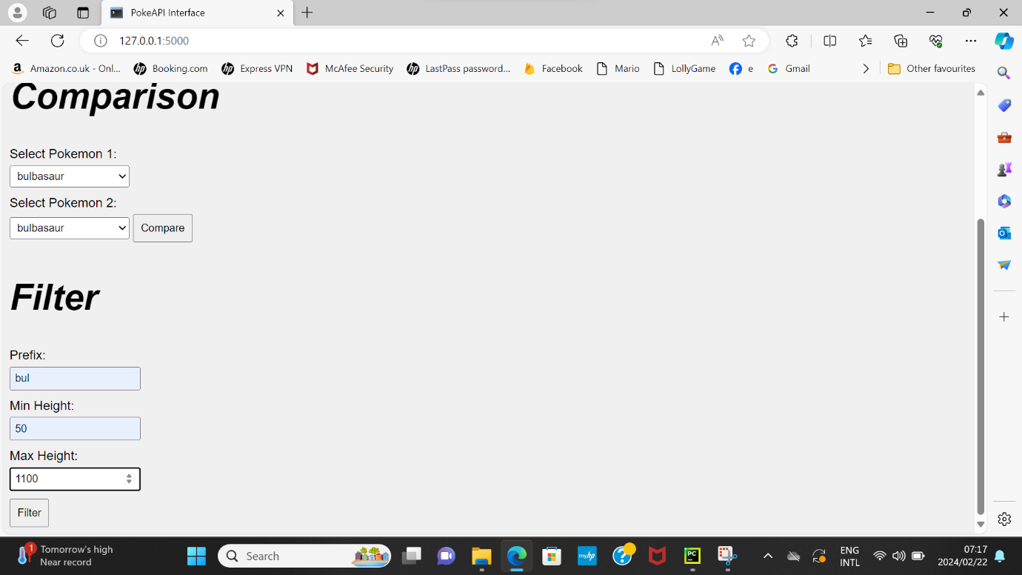

* The user will be able to filter through the different Pokémon based on the prefix of the Pokémon and height, based on the criteria the selected the results will show the filtered Pokémon.

* When a user enters a number that is not between 50 – 1000m, an error message will display. This is due to the height criteria being between 50 – 1000m.